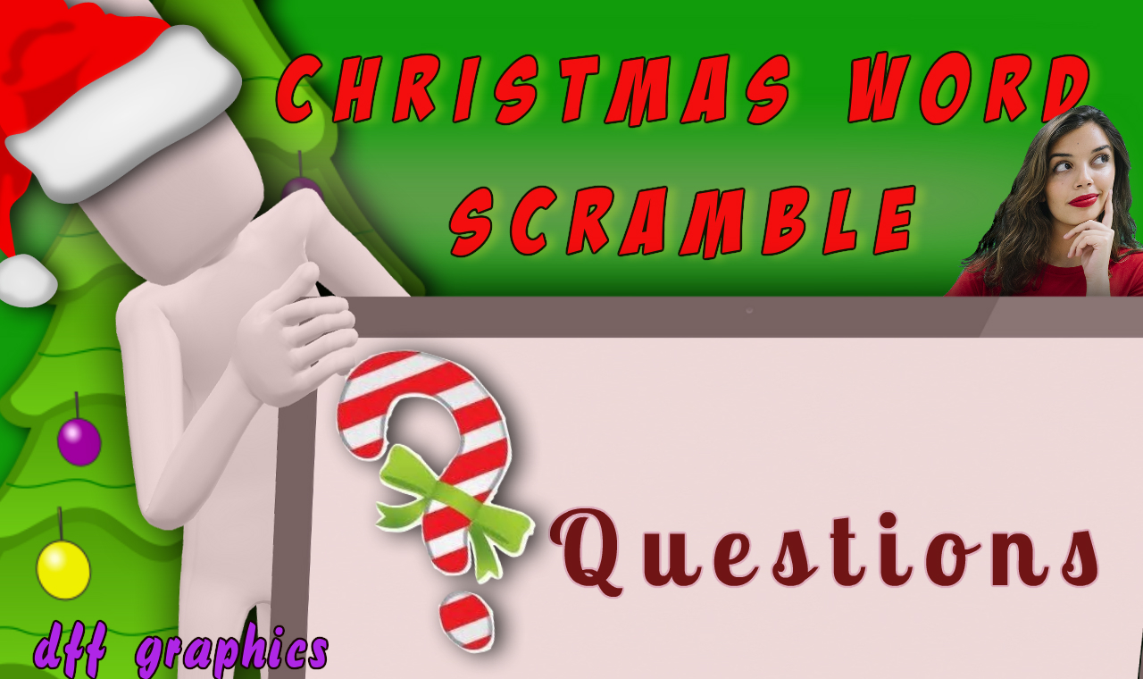

1. denale _ _ _ _ _

2, peodhul _ _ _ _ _ _ _

3. tsicmrhsa _ _ _ _ _ _ _ _ _

4. tnaas _ _ _ _ _

5. wamonsn _ _ _ _ _ _ _

6. rhawte _ _ _ _ _ _

7. denya acbe _ _ _ _ _ _ _ _ __

8. ssjeu _ _ _ _ _

9. tsielmote _ _ _ _ _ _ _ _ _

10. strsnpee _ _ _ _ _ _ _ _

11, hsgile Iselb _ _ _ _ _ _ _ _ _ _ _

12. elon _ _ _ _

13. gaenl _ _ _ _ _

14. ksctgoni _ _ _ _ _ _ _ _

15. edrinere _ _ _ _ _ _ _ _
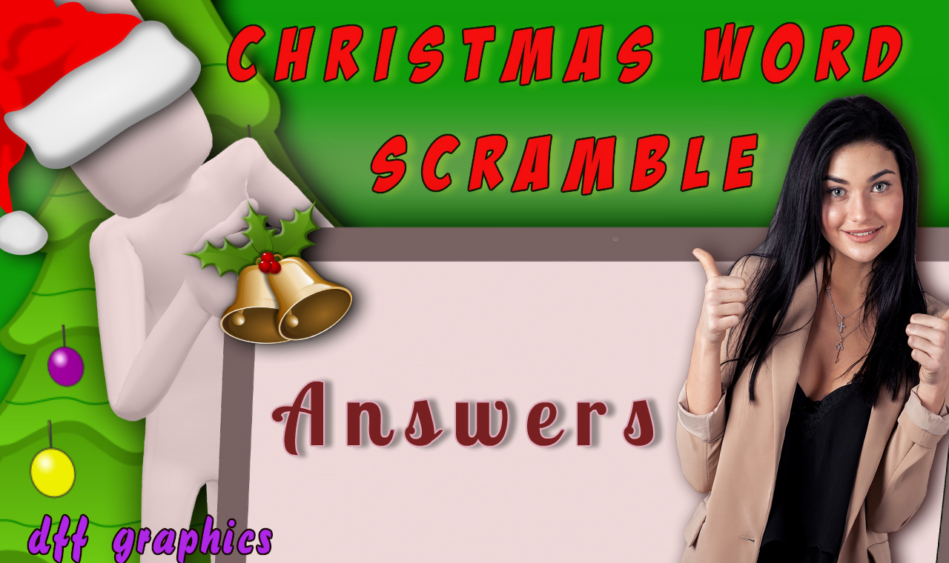

1. denale _ _ _ _ _Candle
2, peodhul _ _ _ _ _ _ _ Rudolph
3. tsicmrhsa _ _ _ _ _ _ _ _ _ Christmas
4. tnaas _ _ _ _ _ Santa
5. wamonsn _ _ _ _ _ _ _Snowman
6. rhawte _ _ _ _ _ _ Wreath
7. denya acbe _ _ _ _ _ _ _ _ __ Candy Cane
8. ssjeu _ _ _ _ _Jesus
9. tsielmote _ _ _ _ _ _ _ _ _ Mistletoe
10. strsnpee _ _ _ _ _ _ _ _Presents
11, hsgile Iselb _ _ _ _ _ _ _ _ _ _ _ Sleigh Bells
12. elon _ _ _ _Noel
13. gaenl _ _ _ _ _Angel
14. ksctgoni _ _ _ _ _ _ _ _ Stocking
15. edrinere _ _ _ _ _ _ _ _ Reindeer

Thanks To Payson Senior Center for this great Xmas Scrabble Game.

